Experiment 23: step motor test
Stepping motor is a kind of electric pulse into the angular displacement of the executive body. Popular point of view: when the stepper driver receives a pulse signal, it drives the stepper motor according to set the direction of rotation of a fixed angle (and step angle). You can control the number of pulses to control the angular displacement, so you can control the pulse frequency to control the motor rotation speed and acceleration, so as to achieve the purpose.
The following is the experimental use of the stepper motor
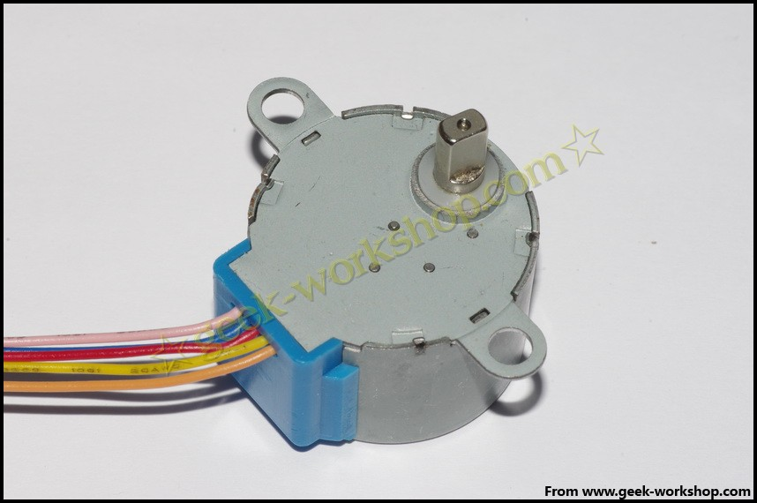

Before using the stepper motor must carefully check the specification, to confirm that the four phase or two phases, how to connect the various lines, this experiment used the stepper motor is the four phase, the different colors of the line is defined as follows
picture：
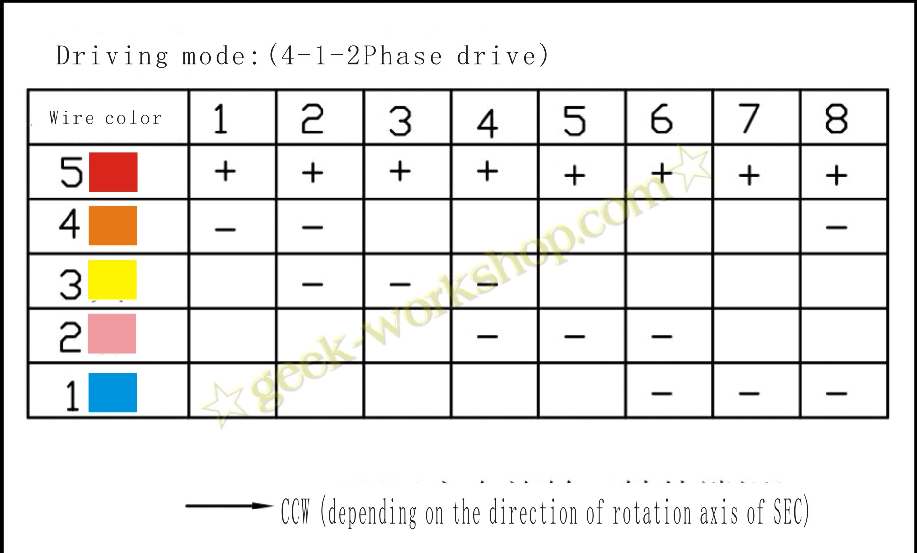
Slow stepping motor

Diameter: 28mm

Voltage: 5V

Step angle: 5.625 1/64 x
Reduction ratio: 1/64
5 line 4 phase can be used with ordinary ULN2003 chip driver, can also be connected to the use of 2 phase
The step into the motor no-load power consumption below 50mA, with 64 times the speed reducer, torque output can drive heavy load, is very suitable for the development board to use. Note: the stepper motor with 64 times the speed reducer, and without reduction of stepper motor compared, speed is slower, is easy for observation, the output shaft stick a piece of cardboard.
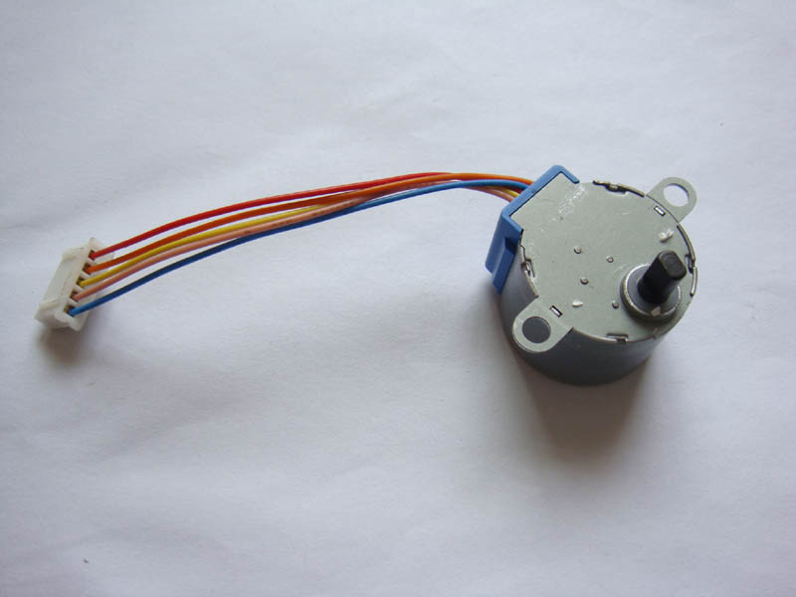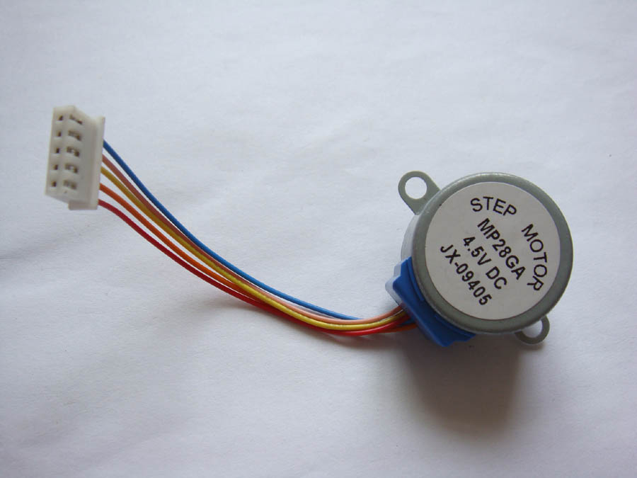

Step motor (five line four phase) driving board (UL2003) test board
Stepping motor drive board (UL2003) test board
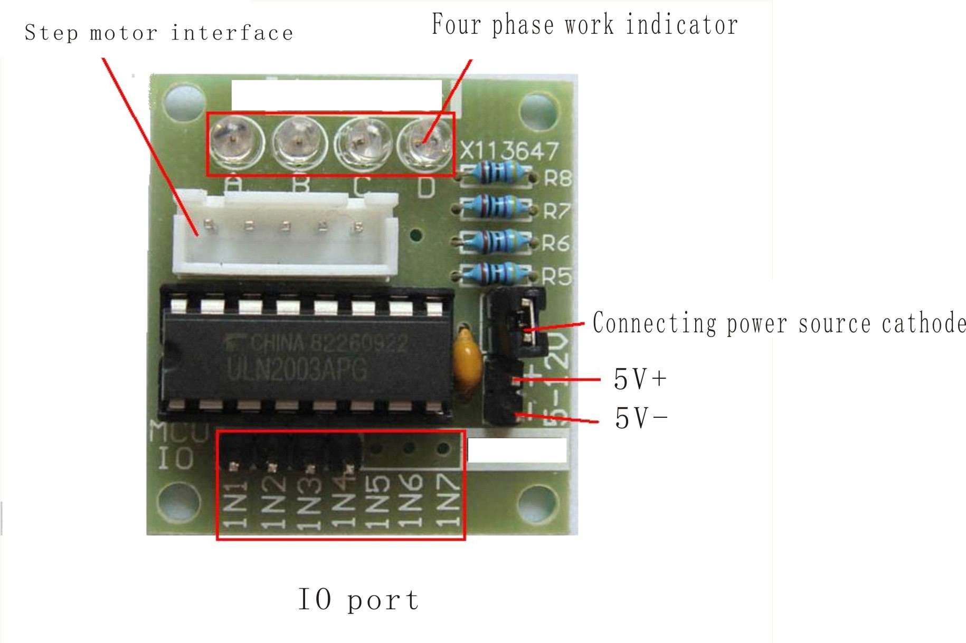

external SIZE：31×35mm
The hardware connection diagram is as follows
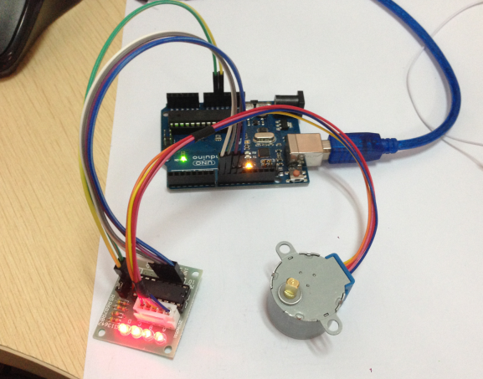

Download the code to the Arduino control panel to see the results.
/*
* Stepper motor with potentiometer rotation
* (or other sensors) using 0 analog inputs
* Use IDE Stepper.h comes with the Arduino library file
#include <Stepper.h>
// Here to set the stepper motor rotation is how many steps
#define STEPS 100
// attached toSet the step number and pin of the stepper motor
Stepper stepper(STEPS, 8, 9, 10, 11);
// Define variables used to store historical readings
int previous = 0;
void setup()
{
// Set the motor at a speed of 90 steps per minute
stepper.setSpeed(90);
}
void loop()
{
int val = analogRead(0); // Get sensor readings
stepper.step(val - previous);// Move the number of steps for the current readings less historical readings
previous = val;// Save historical readings }

Experimental results: the slow rotation of the stepper motor。

